**Assignment 8.1:**

* Get a list of employees who receive a salary less than 100, compared to their immediate employee with higher salary in the same unit.

Prerequisites:

* start all the services: start-all.sh
* start mysql: sudo service mysqld start
* start hive: hive
* create database: create database custom;
* use database: use custom;





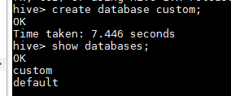

Create employee table:

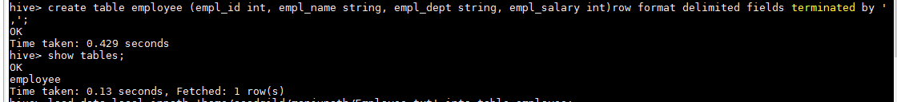

Load data into the table:

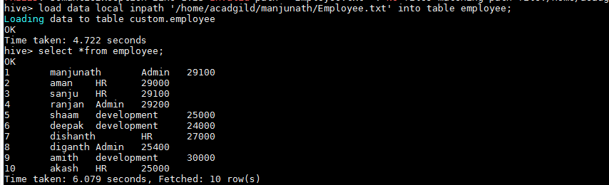

* Get a list of employees who receive a salary less than 100, compared to their immediate employee with higher salary in the same unit

select emp1.empl_id, emp1.empl_name, emp1.empl_dept, emp1.empl_salary from (select empl_id, empl_name, empl_dept, empl_salary from employee) emp1 join (select empl_dept, empl_salary from employee) emp2 on emp1.empl_dept=emp2.empl_dept where emp2.empl_salary>emp1.empl_salary and emp2.empl_salary-emp1.empl_salary=100;

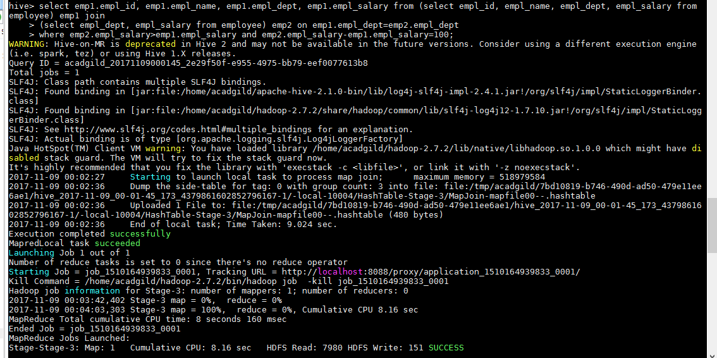

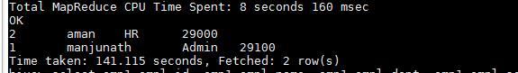

* List of all employees who draw higher salary than the average salary of that department.

select emp1.empl_id, emp1.empl_name, emp1.empl_dept, emp1.empl_salary, emp2.empl_salary from (select empl_id, empl_name, empl_dept, empl_salary from employee) emp1 join (select empl_dept, avg(empl_salary) empl_salary from employee group by empl_dept) emp2 on emp1.empl_dept=emp2.empl_dept where emp1.empl_salary>emp2.empl_salary;

